WASHING MY HANDS
Turn on water
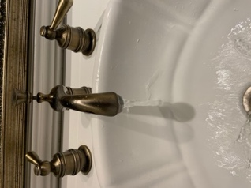

Get soap
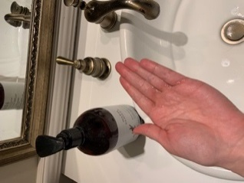

Rub hands
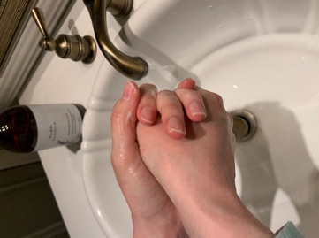
Rinse hands
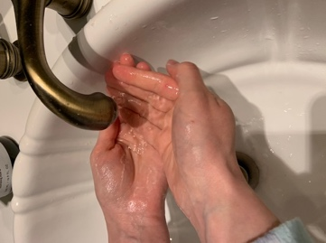

Turn off water
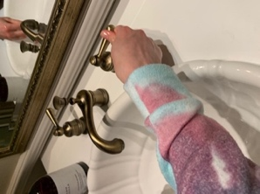

Dry hands
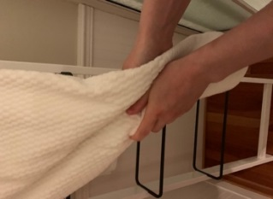

BEGINNER: WASHING HANDS
A visual sequence breaks down a skill into a step-by-step procedure - similar to following a recipe. It can be helpful for individuals who have difficulty remembering what to do next in an activity or a routine. Transforming personal care skills into visual sequences can help individuals become more independent in their daily functioning.

Tips for the implementation of sequence strips:
- Personalize the visuals: Feel free to use the visuals provided in this document as they are or modify them to meet the unique needs of your child. For instance, you might replace the generic images with photos of your child performing the various steps in their home bathroom. You can also add, edit, or remove some steps.
- Location of the visuals: Be sure to place the visual sequence in the location where the task will be completed (e.g., placing brushing teeth visual near the sink) and at a height that is accessible to your child.
- Consistency: Try to use the sequence strips as often as you can. The more you use them, the more likely your child will begin referring to these visuals as part of their routine. Consistent use will help your child to learn the sequence and begin to follow it independently.
- Prompt fading: Initially, your child will require support to follow the sequence of steps. As she/he becomes more comfortable with the visual and the skill, slowly fade the both the amount of support you are offering and reliance on the visual. For instance, you might consider switching from verbal prompts to gestures (e.g., pointing to the next action in the sequence). The gradual fading of prompting is another way to encourage independence.

If you do not have access to a printer, you can use your phone or tablet to create a similar structure. The PicCollage App is one way of designing your own, home-made visual sequence. Click here for a tutorial on how to use this app. With a free Gmail account, you can also use google slides at no cost to create a variety of different visuals that suit your child’s needs.

