VERSION 2: INTERMEDIATE
VISUAL SCHEDULE WITH ANIMATED PHOTOS

How to Implement a Visual Schedule

The use of visual supports helps individuals understand what to expect in the classroom or at home. They also assist children in making transitions from one activity to another. When children understand what is expected of them, independence increases and behaviour difficulties are reduced. Before creating and implementing a visual schedule it is important to understand the child’s individual needs and determine the best way to present information to them.
Visual schedules should provide the following information to the child:
- What is happening today - regular activities; something new, different, unusual
- What is the sequence of the day’s events
- When it is time to stop one activity and move onto another one
- What is changing that I normally expect
Before creating the schedule:
- Decide on the how the events in the day will be displayed - one activity at a time or first-then card (i.e., no reference to chronological time), every 15 minutes, every 30 minutes over the course of a half- or full-day
- Decide on the type and size of visual symbols as it is important that the child is able to derive meaning from the symbol used- see list of symbols below
- Decide how the student will know when an event or activity is over –checking off a done column (samples provided below), turning the symbol over, putting the symbol in pocket, etc.
- Decide on the location of the schedule – In transition area, on a wall, on the child’s desk, or in a portable agenda, iPad, etc.
The list of symbols from most concrete to abstract include:
- photographs
- abstract pictures (line drawings)-pictograms
- a combination of symbols (example-pictures and words)
- printed and written words
Using a daily schedule:
Place the symbols in the order that the activities are to be followed in the morning. The amount of time spent on each activity does not matter. It is the sequence of events that is important. Review all of the symbols on the schedule with the student at the beginning of the day by pointing to each one and labeling each activity. Use sequence words such as “First it’s time for ______, then you will ______, after its _______ etc.” The symbols are there to provide important information to your student about their day. After lunch repeat the process for the afternoon schedule.
General tips for using daily schedules:
- FOLLOW IT!
- Make it an essential part of the daily routine – REMEMBER: visual schedules can be modified to meet the child’s needs but they should rarely be eliminated
- Always refer back to the schedule when communicating about its information with the child
- Once the schedule is in place and the child understands the system, he/she should be able to refer to it and follow it without your prompting.
Sample visual schedules:

Here is a sample visual schedule to help structure your day. The blank strip is used to place the pictures in the order that you see fit for any given day. As every day is slightly different, you can arrange the activities in a new order daily to reflect the sequence of events for that day. It is provided here as both a word document that you can adapted to your own liking as well as a PDF if you want to simply print as is. If you don’t have access to a printer, you can use your phone to create a similar structure using pictures and collage for example (https://www.youtube.com/watch?v=STpB4GpOzw4) or an app “Visual Schedules Lite App” for example. For more details, please check out the Communication Corner of the ASD newsletter and the materials tab on the Centre of Excellence for ASD webpage.

MY SCHEDULE
TO DO | DONE
MY SCHEDULE
TO DO | DONE

OUTSIDE PLAY   | MUSIC  
LUNCH   | SPECIAL ACTIVITY  
SNACK   | CHOICE  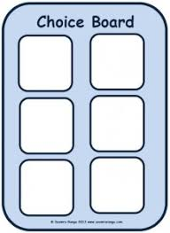
WORK AT DESK   | ART & CRAFT TIME  
PHYSICAL EDUCATION   | BUS RIDE  
HOME   | LIBRARY VISIT  
COMPUTER TIME  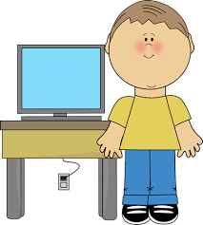 | PUZZLE TIME  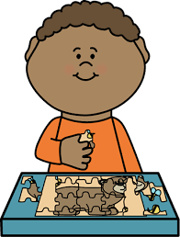

HOME   | LIBRARY VISIT  
COMPUTER TIME | PUZZLE TIME
iPad   | READING TIME  
PLAYTIME   | BEDTIME  
SHOWER TIME   | BRUSH TEETH  

