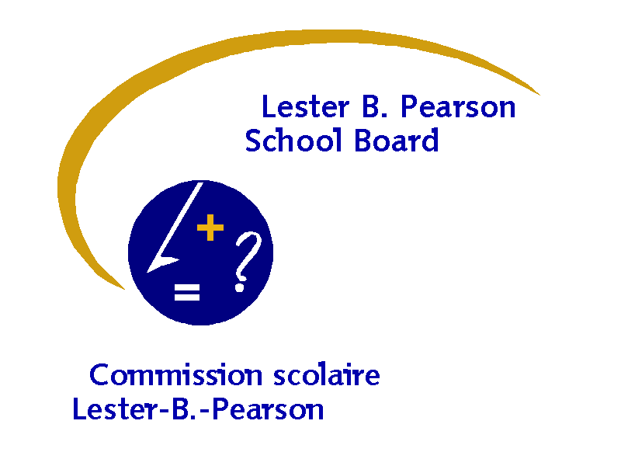


STUDENT PROFILE

Name: _______________________________________________ Date: ______________________

School: _______________________________________________ Grade: _____________________

Family Constellation: __________________________

Case Manager: _____________________________

Siblings: ______________________________________ Birth Order: _________________

1. GENERAL OBSERVATIONS:

IMPRESSIONS:

LIKES:

DISLIKES:

2. PRESENT SUPPORTS:

(Date of assessment, aide time allocation, specialized interventions, reports in file etc…)
PERSONS INVOLVED  (Names): | INTERVENTIONS, DATES ETC…
PERSONS INVOLVED  (Names): | Yes | Name | Comments
SCHOOL RESOURCE :
INTEGRATION AIDES:
CONSULTANT FOR
SPECIAL NEEDS:
CONSULTANT FOR
AUTISM:
SPEECH AND
LANGUAGE:
PSYCHOLOGIST:
OCCUPATIONAL
THERAPIST:

OUTSIDE AGENCIES:

3. CURRENT AREAS OF FUNCTIONING

AREAS | STRENGTHS AND NEEDS
COGNITIVE SKILLS
/ADADEMICS:
LEARNING STYLE
LANGUAGE AND COMMUNICATION SKILLS (RECEPTIVE AND EXPRESSIVE)
DAILY LIVING SKILLS
(DRESSING, TOILETING,
FEEDING, ETC…)
FINE AND GROSS
MOTOR
SOCIAL SKILLS
EMOTIONAL
/BEHAVIORAL
LEISURE SKILLS

4. MISCELLANEOUS INFORMATION

- MEDICAL ISSUES / MEDICATIONS:
- PENDING REFERRALS:
[Internal (OT, Speech); External (Psychiatrist, Pediatrician)]:

5. GENERAL RECOMMENDATIONS:

SUBMITTED BY:

NAME(S) TITLE(S)

