Class Rules
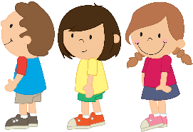Line up nicely
Raise your hand
Walk in hallways
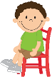Stay in your seat
Listen to the teacher
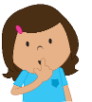Work quietly
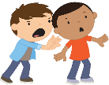Hands to yourself

