Date:

At school I:

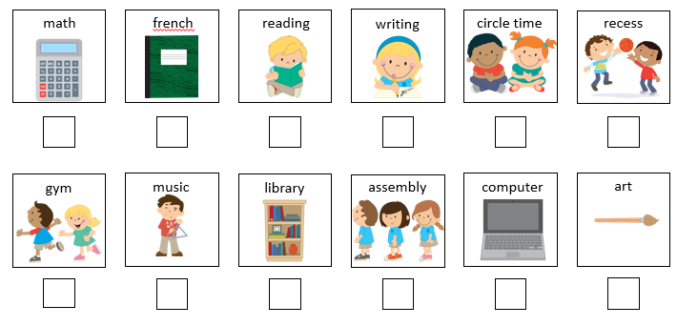

______________________________________________________________________________

Notes:_______________________________________________________________________________________________________________________________________________________________________________________________________________________________________________________________________________________________________________________________________________________________________________________________________________________________________________________________________________

Date:

At home I:

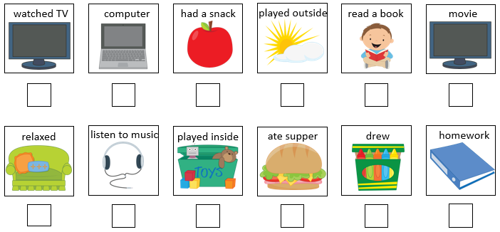

Parent comments:

_________________________________________________________________________________________________________________________________________________________________________________________________________________________________________________________________________________________________________________________________________________________________________________________________________________________________________________________________________________________________________________________________________________________________________________________________________________________________________________________________________________________________________________________________________________________________